High Speed Door |  |  | 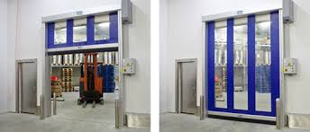
Details | Albany | Customer Requirement
Application of Door | Internal/External/Hygiene area/Machine Protection
Description | Flexible High-Performance Door, opening in vertical direction for interior/ Exterior Applications
Self-supporting side frames | GI/Alu/SS
Door curtain | Made of transparent PVC material with coated fabric reinforcement stripes, ultramarine (similar to RAL 5002)  or red (similar to RAL 3002).
Top roll | GI/ALu/S S
Wind Pressure | Class 1/ Class2/ Class 3
Drive unit | Hollow shaft gear motor.
Protection | IP 55
Control system | ACS 50 / MCC Vector Controller
Supply voltage | 3L/(N)PE 220/230/380/400/415V; 50Hz Transformer necessary for 440/480/500V
Safety devices | Electrical safety contact edge, door line photocell, drop down protection integrated in gear box.
Manual activation | By means of a crank.
Opening / closing Speed | Up to max. 1.0 / 1.0 m/s. and 2.0 m/s
Size max | (DW x DH) 6000 x 6000 mm
Make | ALBANY RapidRoll® 300
Covers | Top roll cover  Motor cover
Vision Window | Vertical Vision Strips
Accessories | - Loop Detector  - Radar sensor  - Extra photocell  - Extra push button  - Flashing light
Delivery | 9 to 10 weeks from date of drawing approval & Advance payment

